Let Newtek take care of your Payroll & HCM Service needs
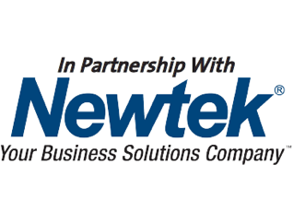

https://www.istockphoto.com/photo/businessman-opening-envelope-with-paycheck-gm1000964802-270620911
Paying employees and dealing with taxes can be enough to overwhelm the most efficient business owner. Our Payroll Service provides you with a complete payroll processing solution, including complete quarterly and year-end reporting. With our service, you can relax and leave the payroll hassle to us.

Our Services Include:

- PAYMENTS OPTIONS / PAYROLL MANAGEMENT

- TAX MANAGEMENT

- EMPLOYEE SELF SERVICE

- PAY CARDS

- Workers Compensation

- And much more.
For more information:
Contact Miguel Chapa | Regional Vice President
Email: MChapa@Newtekone.com
Office: 212-356-9500 x11007
Cell: 956-579-8293
www.newtekone.com

